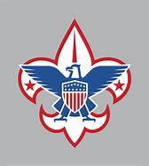

Calling all Artists!!! We need your help!!!!

Our recently formed Northampton District of Minsi Trails Council needs our own patch, and we are asking you to please help! We want our District Scouts to submit ideas/sketches/drawings for a patch to be pulled from our local Northampton County area and incorporating elements from Scouting. Below are some guidelines to help frame your imagination.

- Ideas drawn from our local communities across all of Northampton District.
- Limit no more than 6 colors.
- Please keep the size to no more than 3 inches in any one direction.
- Shape – The patch can be square, rectangular, round, oval and even a specialty shape.
- Design a patch that can be worn either on the upper right sleeve, the right pocket, or, hung on a loop from the right pocket.

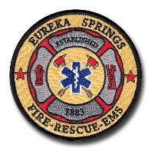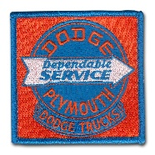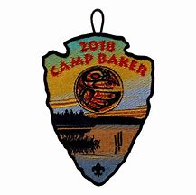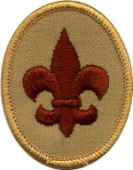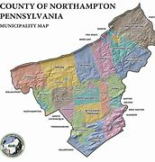 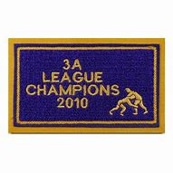 ???
Round Square Arrowhead Oval Unique Rectangle

Design submissions become the sole property of Minsi Trails Council. It is possible that design ideas could be refined and possibly combined with other submissions to develop the final product

Please submit your ideas no later than July 31,2022 to Mike Caffrey at mikecee1062@yahoo.com.

The winner will be awarded the first Northampton District Patch.

For more information, please email or call 610-295-8816.

Thank you and please let your imaginations run wild!!

